

**STM32F2xx 시리즈의 특성**

* Core: ARM 32-bit Cortex™-M3 CPU with Adaptive real-time accelerator (ARTAccelerator™) allowing 0-wait state execution performance from Flash memory, frequency up to 120 MHz, memory protection unit, 150 DMIPS/1.25 DMIPS/MHz (Dhrystone 2.1)
* Memories
  + Up to 1 Mbyte of Flash memory
  + 512 bytes of OTP memory
  + Up to 128 + 4 Kbytes of SRAM
  + Flexible static memory controller that supports Compact Flash, SRAM, PSRAM, NOR and NAND memories
  + LCD parallel interface, 8080/6800 modes
* Clock, reset and supply management
  + From 1.65 to 3.6 V application supply and I/Os
  + POR, PDR, PVD and BOR
  + 4 to 26 MHz crystal oscillator
  + Internal 16 MHz factory-trimmed RC (1% accuracy at 25 °C)
  + 32 kHz oscillator for RTC with calibration
  + Internal 32 kHz RC with calibration
* Low power
  + Sleep, Stop and Standby modes
  + VBAT supply for RTC, 20 × 32 bit backup registers, and optional 4 KB backup SRAM
* 3 × 12-bit, 0.5 μs A/D converters
  + up to 24 channels
  + up to 6 MSPS in triple interleaved mode
* 2 × 12-bit D/A converters
* General-purpose DMA
  + 16-stream DMA controller with centralized FIFOs and burst support
* Up to 17 timers
  + Up to twelve 16-bit and two 32-bit timers, up to 120 MHz, each with up to 4 IC/OC/PWM or pulse counter and quadrature (incremental) encoder input
* Debug mode
  + Serial wire debug (SWD) & JTAG interfaces
  + Cortex-M3 Embedded Trace Macrocell™
* Up to 140 I/O ports with interrupt capability:
  + Up to 136 fast I/Os up to 60 MHz
  + Up to 138 5 V-tolerant I/Os
* Up to 15 communication interfaces
  + Up to 3 × I2C interfaces (SMBus/PMBus)
  + Up to 4 USARTs and 2 UARTs (7.5 Mbit/s,ISO 7816 interface, LIN, IrDA, modem control)
  + Up to 3 SPIs (30 Mbit/s), 2 with muxed I2S to achieve audio class accuracy via audio PLL or external PLL
  + 2 × CAN interfaces (2.0B Active)
  + SDIO interface
* Advanced connectivity
  + USB 2.0 full-speed device/host/OTG controller with on-chip PHY
  + USB 2.0 high-speed/full-speed device/host/OTG controller with dedicated DMA, on-chip full-speed PHY and ULPI
  + 10/100 Ethernet MAC with dedicated DMA: supports IEEE 1588v2 hardware, MII/RMII
* 8- to 14-bit parallel camera interface: up to 48 Mbyte/s
* CRC calculation unit, 96-bit unique ID
* Analog true random number generator

**STM32F2xx Part numbering**

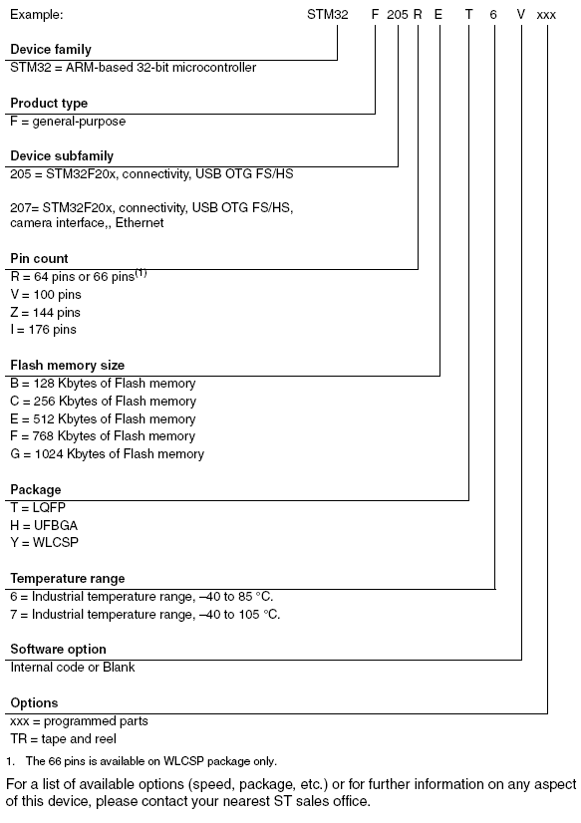

**STM32F207VGT 기능 및 주변 장치**

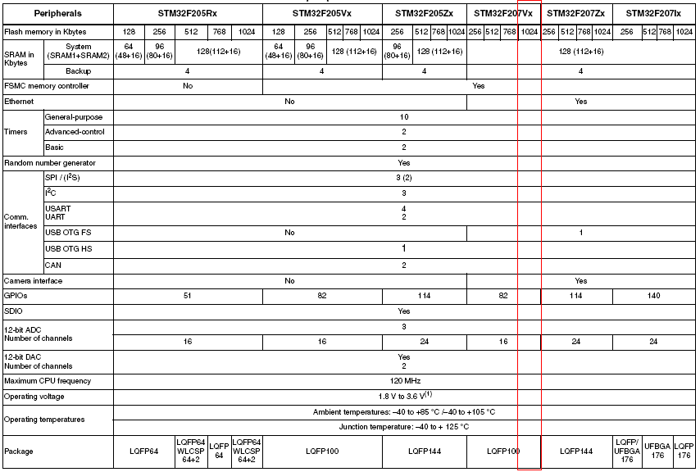

**Mango-M32F2 BOARD SPECIFICATION**

* STM32F207VGT : Coretex-M3 기반 ST Microelectronics사의 Micro-Controller
* 100 Pin LQFP
* 1024 Kbytes of Flash memory
* 2 Port RS-232C Interface
* 1 Port USB 2.0 FS Device Interface
* 1 Port USB HOST FS
* 1 Port Ethernet
* 1 Port UART for GPS
* 1 Port UART for ZigBee
* 3 Indicator LEDs
* 2 USER Key
* 1 Reset Key
* 1 Boot Select Switch
* 2 X 100 HEADER for Expansion

**Mango-M32F2 BLOCK DIAGRAM**

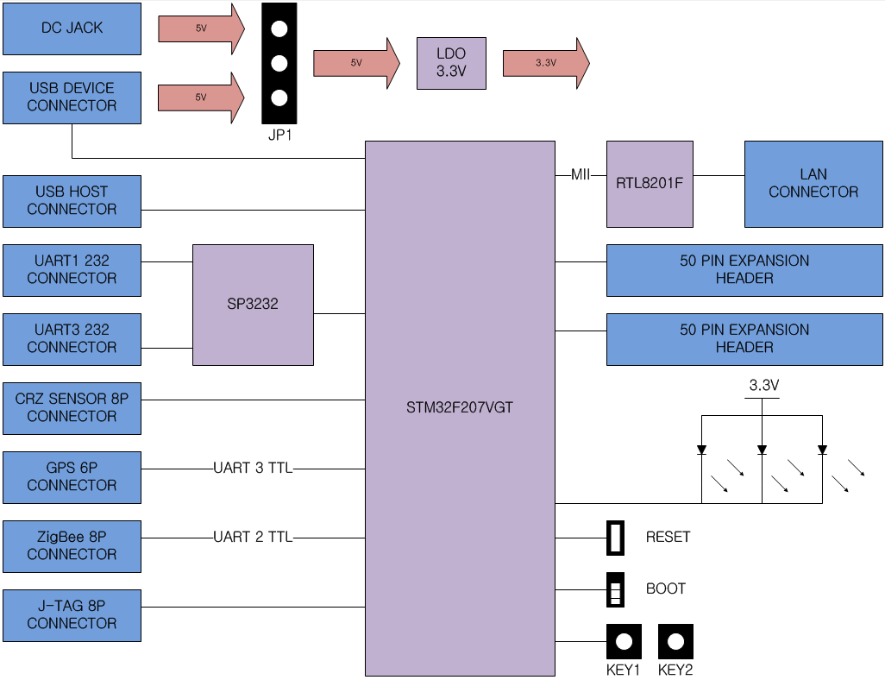

**Mango-M32F2 부품 면 설명**

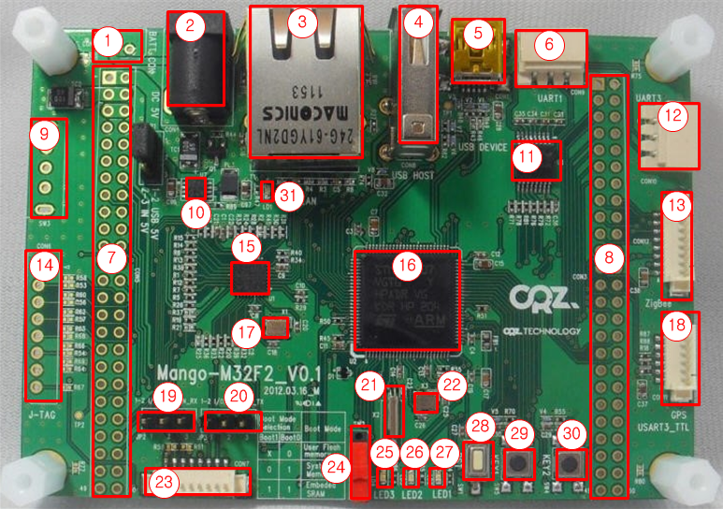

|  |  |  |  |
| --- | --- | --- | --- |
| 번호 | 설명 | 번호 | 설명 |
| 1 | 배터리 커넥터 | 2 | DC 5V 어댑터 커넥터 |
| 3 | 랜 커넥터 | 4 | USB HOST 커넥터 |
| 5 | USB DEVICE 커넥터 | 6 | RS232 Port #3 커넥터 |
| 7 | 50핀 확장 커넥터 A | 8 | 50핀 확장 커넥터 B |
| 9 | DC 5V ON/OFF 스위치 | 10 | 3.3V DC/DC |
| 11 | SP3232 UART Level Converter | 12 | RS232 Port #1 커넥터 |
| 13 | ZigBee 연결 커넥터 | 14 | J-TAG 커넥터 |
| 15 | Ethernet PHY IC | 16 | STM32F207VGT |
| 17 | 25Mhz Crystal for Ethernet PHY | 18 | GPS 연결 커넥터 |
| 19 | 센서보드 IO/CAN 선택 점퍼 A | 20 | 센서보드 IO/CAN 선택 점퍼 B |
| 21 | 32.768 KHz Crystal for STM32 | 22 | 25 MHz Crystal for STM32 |
| 23 | 센서보드 연결 켜넥터 | 24 | Boot Select Switch (BOOT0) |
| 25 | LED3 | 26 | LED2 |
| 27 | LED1 | 28 | Reset Switch |
| 29 | KEY 1 | 30 | KEY 2 |
| 31 | Power LED |  |  |

**입력 전원**

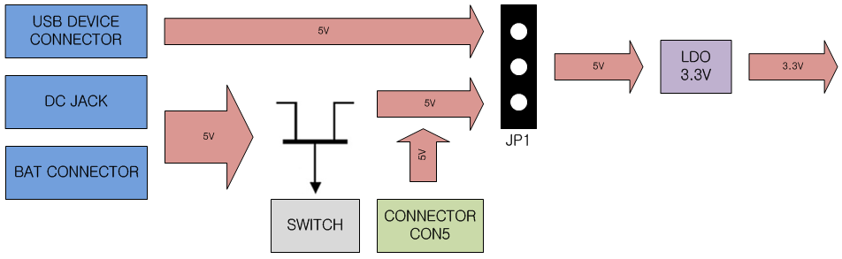

Mango-M32F2 는 위와 같이 입력 전원으로 구성 되어 있습니다.

입력 전원 소스는 3 종류입니다.

USB DEVICE 커넥터로 공급되는 5V를 사용 하시려면, JP1 점퍼를 1,2번 핀으로 설정해 주셔야 합니다. 이때, 보드에 전원이 얼마나 소모하는지 확인 합니다. USB 포트마다 출력해주는 전류가 다르기 때문입니다.

DC JACK과 CONNECTOR(CON5)로 전원 입력을 받으려면, JP1 점퍼를 2,3번 핀으로 설정해 주셔야 합니다. DC JACK 은 스위치를 꼭 ON 해주어야 전원이 인가 되며, CONNECTOR로 공급되는 5V는 바로 인가 됩니다.

**USB FS Host 커넥터**

**USB FS Device 커넥터**

**RS232 Port #1 커넥터**